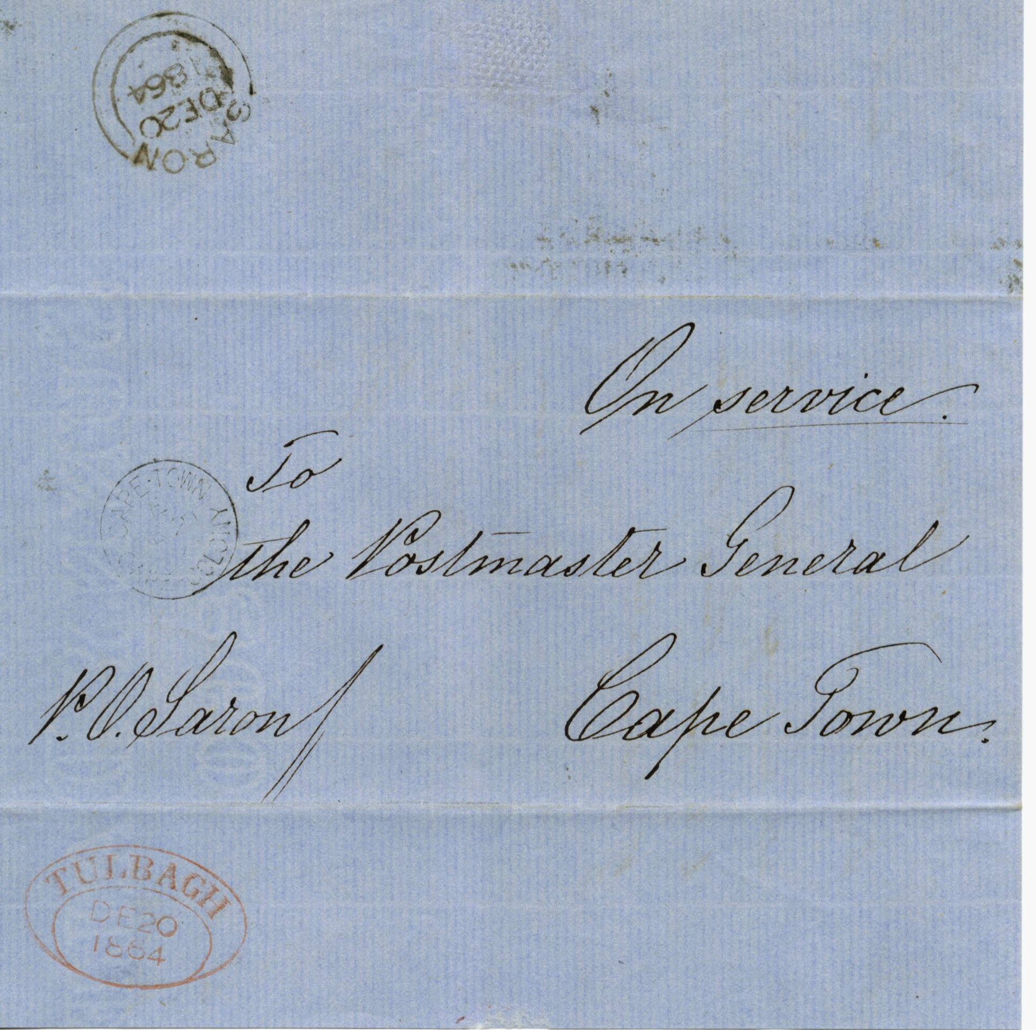
+

TULBACH TOWN OVAL HANDSTAMP

186 on H M Service pale blue outer letter sheet, from the Blanco post office showing a fine black strike of the “Blanco D.T.O.” of 12th January 1863. Cape Town receiving cds on front dated “JA 14 65”.

1864 wrapper P.O. Saron to cape Town light blue “On Service” outer letter sheet from the tiny mission station at Saron with top backflap opened and showing a fine “double arc” cancel of Saron dated “DE 20 1864” addressed to the Postmaster General at Cape Town bearing in addition town oval transit in red on bottom backflap, Tulbagh “DE 20 1864” plus Cape Town arrival on address panel, opened out for display, an extremely rare postmark.

CAPE OF GOOD HOPE

DEVELOPENT OF POSTAL SERVICES

The Dated Town Oval

Handstamps of 1853

